**VISVESVARAYA TECHNOLOGICAL UNIVERSITY**

**“Jnana Sangama”, Belgaum -590014, Karnataka.**



**PROJECT WORK-2 REPORT**

**On**

**“DIGIMELODY”**

***Submitted by***

**AKSHAY S (1BM23CS022)**

**ARPITH GOWDA H S (1BM23CS053)**

**AKSHAT KUMAR SINHA (1BM23CS021)**

**AMAN VATS (1BM23CS026)**

***Under the Guidance of***

|  |  |
| --- | --- |
| **SANDHYA KULKARNI**  **ASSISTANT PROFESSOR** |  |

***in partial fulfillment for the award of the degree of***

**BACHELOR OF ENGINEERING**

***in***

**COMPUTER SCIENCE AND ENGINEERING**



**B.M.S. COLLEGE OF ENGINEERING**

**(Autonomous Institution under VTU)**

**BENGALURU-560019**

**Mar 2024**

**B. M. S. College of Engineering,**

**Bull Temple Road, Bangalore 560019**

(Affiliated To Visvesvaraya Technological University, Belgaum)

**Department of Computer Science and Engineering**



**CERTIFICATE**

This is to certify that the project work entitled **“DIGIMELODY”** carried out by **AKSHAY S (1BM23CS022),ARPITH GOWDA H S (1BM23CS053),AKSHAT**

**KUMAR SINHA (1BM23CS021),AMAN VATS (1BM23CS026)** who are bonafide students of **B. M. S. College of Engineering.** It is in partial fulfillment for the award of **Bachelor of Engineering in Computer Science and Engineering** of the Visveswaraya Technological University, Belgaum during the year 2024. The project report has been approved as it satisfies the academic requirements in respect of **Full Stack Web Development(23CS3AEFWD)** work prescribed for the said degree.

Signature of the Guide                 Signature of the HOD

Sandhya Kulkarni Dr. Kavitha Sooda

Assistant Professor Prof & Head of Dept of CSE

BMSCE, Bengaluru BMSCE, Bengaluru

External Viva

Name of the Examiner                                                               Signature with date

**B.M.S. College of EngineerinG**

**DEPARTMENT OF COMPUTER SCIENCE AND ENGINEERING**



**DECALARATION**

We, **AKSHAY S (1BM23CS022), ARPITH GOWDA H S (1BM23CS053),**

**AKSHAT KUMAR SINHA (1BM23CS021), AMAN VATS (1BM23CS026)**

students of 3rd Semester, B.E, Department of Computer Science and Engineering, BMS College of Engineering, Bangalore, hereby declare that, this Full Stack Web Development entitled **"DIGIMELODY"** has been carried out by us under the guidance of Sandhya Kulkarni, Assistant Professor, Department of CSE, BMS College of Engineering, Bangalore during the academic semester Dec 2023 - Mar 2024.

We also declare that to the best of our knowledge and belief, the development reported here is not from part of any other report by any other students.

Signature

**AKSHAY S (1BM23CS022)**

**ARPITH GOWDA H S (1BM23CS053)**

**AKSHAT KUMAR SINHA (1BM23CS021)**

**AMAN VATS (1BM23CS026)**

**TABLE OF CONTENTS**

|  |  |  |
| --- | --- | --- |
| **Serial**  **No.** | **TITLE** | **PAGE NO.** |
| 1 | **Introduction** | 1 |
| 1.1 | Overview | 1 |
| 1.2 | Motivation | 1 |
| 2 | **Software Requirement Specification** | 2 |
| 2.1 | Hardware Requirements | 2 |
| 2.2 | Software Requirements | 2 |
| 3 | **ER diagram of the project** | 3 |
| 4 | **Schema of project** | 4 |
| 5 | **User Interface Design** | 5 |
| 5.1 |  | 5 |
| 5.2 |  | 6 |
| 5.3 |  | 7 |
| 5.4 |  | 9 |
| 5.5 |  | 10 |
| 5.6 |  | 10 |
| 5.7 |  | 18 |
| 5.8 |  | 18 |
| 5.9 |  | 22 |
| 5.10 |  | 22 |

**INTRODUCTION**

* 1. **Overview**

This Music Website Project is a web development initiative focused on creating an engaging online platform that offers a variety of music-related features. The goal is to provide users with easy access to music content, personalized experiences, and tools for discovering, sharing, and enjoying music. Below is a detailed overview of the components, features, and objectives of the project.

* 1. **Motivation**

The motivation for this project is driven by the desire to create a more engaging, and more personalized music experience for users. It aims to tap into the changing landscape of music consumption, offering a platform that blends entertainment, social interaction, music discovery, and artist engagement. By addressing gaps in current offerings and adding innovative features, this music website has the potential to become a go-to destination for music lovers of all kinds.

For the **Music Website Project**, the motivation involves several factors, such as:

* **Meeting the needs of music lovers**: The motivation comes from a desire to provide an enhanced, personalized music experience that goes beyond just listening to music, by offering social features, artist discovery, and community engagement.
* **Filling gaps in the market**: The project is motivated by the realization that existing music platforms often fail to deliver the depth of personalization, social interaction, and exclusive content that users crave. There is an opportunity to create a unique platform that better meets the demands of modern music consumers.
* **Leveraging technology to improve user experience**: The motivation includes using advancements in technology to create a more interactive and engaging music discovery process.
* **Supporting artists and independent musicians**: Another motivator is the desire to give emerging artists a platform to share their music and engage directly with fans, addressing the challenges independent musicians face in gaining visibility on larger platforms.
* Ultimately, the motivation outlines the **reason for the project’s existence**, guiding its design, features, and long-term goals. It provides a sense of purpose for the people involved, whether they are developers, designers, or stakeholders, and helps ensure the project remains aligned with its core objectives throughout its lifecycle.

**SOFTWARE REQUIREMENTS**

**2.1 Hardware Requirements:**

* A PC with the following or greater specifications:
  + Intel Core i7 or higher
  + Intel evo i5
  + 16 GB RAM
  + 8 GB RAM
  + 500 GB Hard Drive
  + 512GB
* A stable internet connection (2Mbps or higher)

**2.2 Software Requirements:**

* Operating system : Windows, Linux,
* Front end technologies are : HTML, CSS, JavaScript,
* IDE : VS Code,Sublime text
* Back end requirement : PHP/Node.js
* Server : XAMPP server/Node.js

**3. ER DIAGRAM OF THE PROJECT**

EQUIP_NAME

EQUIP_NO

PASSWORDD

**EQUIPMENT_INFO**

EMAIL

SKILL

ADDS

EQUIP_QTY

TRAINER_ID

**TRAINER_INFO**

PASSWORDDDD

ADMIN M N

ADDS

TRAINER_NAME

USERNAME

USERNAME

TEACHESS

ADDS

ATTENDED

PASSWORD

CLASS_ID

M N

M

TRAINER_ID

FIRST

LAST

M

AGE

**CLASSES**

CLASS_NAME

GENDERR

**MEMBER_INFO**

N

DOB

TRAINER_NAME

USERNAMEE

CONTACTT

ATTENDED

EMAIL

M

M

CLASS_NAME

PAYS

USERNAME

SLNO

DAYS

FEE

N

FIRST

MUSER

**ATTENDANCE**

LAST

TUSER

**PAYMENT**

**4. SCHEMA OF THE PROJECT**

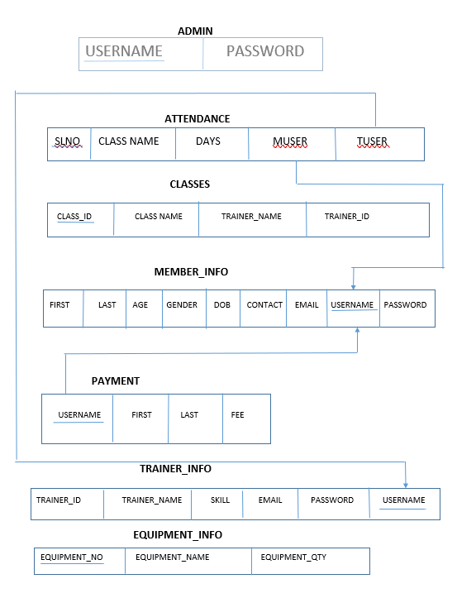

**USER INTERFACE DESIGN**

**Attach various screenshots of each page along with a brief discussion. Please give Figure numbers and names to each of the screenshot attached.**

**REFERENCES:**

**Please provide all the website links you used as reference to build the project**

* <https://www.w3schools.com/>
* <https://chatgpt.com/>
* <https://www.canva.com/website-builder/>
* <https://code.visualstudio.com/>
* <https://www.mongodb.com/>
* <https://nodejs.org/en>
* <https://www.geeksforgeeks.org/html-tutorial/>
* <https://www.w3.org/Style/CSS/Overview.en.html>
* <https://www.javascripttutorial.net/>
* <https://stackoverflow.com/questions/19767510/using-a-database-to-store-and-get-html-pages-for-website>
* <https://www.geeksforgeeks.org/backend-development/>
* <https://www.w3schools.com/howto/howto_blog_become_frontenddev.asp>